Honors Chemistry
Model of the Atom
Lab 2
Ionized Gas

Background
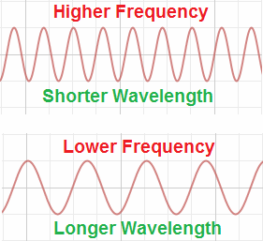
What is light? Such a simple question with such a deep, rich answer. Light is a collection of photons moving together in a wave-like motion. Our eyes observe different colors of light depending on both the wavelength and the frequency of the wave. The amount of energy the wave contains truly determines the color our eyes perceive. A wave with a large amount of energy will have a high frequency and a short wavelength. Conversely, a wave with a small amount of energy will have a low frequency and a long wavelength. Very specific wavelengths will appear as a distinct color. This is a brief explanation of what light is, the question still remains for you to answer…where does light come from?

Objective
Figure 1. A comparison of two waves - high frequency, short wavelength and low frequency, long wavelength.
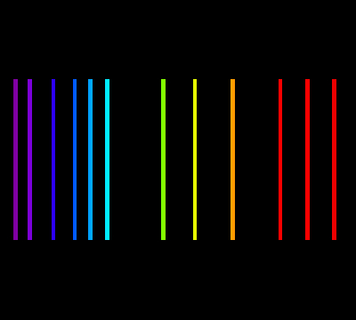
You will work in pairs to collect data using a spectrophotometer. Through your spectrophotometer, you will observe a set of spectral lines, similar to those in Figure 2. Each line is a different color, which must represent a different wavelength, therefore a different amount of energy. It is up to you and your partner to determine what the energy is for each spectral line and why there are various energies for each ionized gas chamber we observe. We will observe several tubes in class, you are only responsible for writing about two in your lab report.

Pre-Lab
Watch the Electromagnetic Radiation video.

Procedure
Figure 2. Spectal lines as seen through a spectrophotometer.
We will discuss how to use the spectrophotometers in class.

Post-Lab Assessment
In other words, what should I (the student), know after I’ve successfully completed.
- Within your GROUP lab report, you should correctly use all of the underlined words from the Background section.
- You should provide a table that includes the gas observed, the color of the spectral lines, the wavelength and frequency of the spectral lines, and the energy associated with each spectral line.
- You should provide a summary of why we observe several spectral lines for each gas observed.

