AP Chemistry
Summer
Prerequisite Review

Visit us at chemistrywithrourke.weebly.com

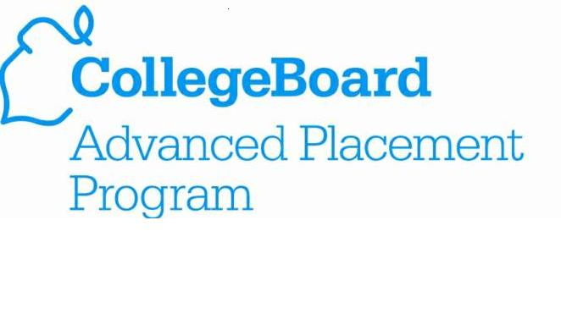

Adapted from: Bergmann-Sams

Congratulations! Your student has been selected to enroll in the AP Chemistry course for the 2013-2014 school year. This is a highly selective and fast-paced course that only students of your son/daughter’s academic caliber are prepared to succeed. Please take a few minutes to read through the following choice excerpts from the AP College Board Chemistry Course Description website. For further information, please feel free to visit http://apcentral.collegeboard.com/apc/public/repository/ap-chemistry-course-description.pdf.

AP ® enables students to pursue college-level studies while still in high school. AP provides willing and academically prepared students with the opportunity to earn college credit, advanced placement, or both. Taking AP courses also demonstrates to college admission officers that students have sought out the most rigorous course work available to them. Each AP course is modeled upon a comparable college course, and college and university faculty play a vital role in ensuring that AP courses align with college-level standards. Talented and dedicated AP teachers help AP students in classrooms around the world develop and apply the content knowledge and skills they will need in college. Each AP course concludes with a college-level assessment developed and scored by college and university faculty as well as experienced AP teachers. AP Exams are an essential part of the AP experience, enabling students to demonstrate their mastery of college-level course work. More than 90 percent of four-year colleges and universities in the United States grant students credit, placement, or both on the basis of successful AP Exam scores. Universities in more than 60 countries recognize AP Exam scores in the admission process and/or award credit and placement for qualifying scores. Visit www.collegeboard.org/ap/creditpolicy to view AP credit and placement policies at more than 1,000 colleges and universities. Performing well on an AP Exam means more than just the successful completion of a course; it is a pathway to success in college. Research consistently shows that students who score a 3 or higher on AP Exams typically experience greater academic success in college and are more likely to graduate on time than otherwise comparable non-AP peers.

The exam scoring process, like the course and exam development process, relies on the expertise of both AP teachers and college faculty. While multiple-choice questions are scored by machine, the free-response questions are scored by thousands of college faculty and expert AP teachers at the annual AP Reading. AP Exam Readers are thoroughly trained, and their work is monitored throughout the Reading for fairness and consistency. In each subject, a highly respected college faculty member fills the role of Chief Reader, who, with the help of AP Readers in leadership positions, maintains the accuracy of the scoring standards. Scores on the free-response questions are weighted and combined with the weighted results of the computer-scored multiple-choice questions. These composite, weighted raw scores are converted into the reported AP Exam scores of 5, 4, 3, 2, and 1. In general, the AP composite score points are set so that the lowest raw score needed to earn an AP Exam score of 5 is equivalent to the average score among college students earning grades of A in the college course. Similarly, AP Exam scores of 4 are equivalent to college grades of A–, B+, and B. AP Exam scores of 3 are equivalent to college grades of B–, C+, and C.

The AP Chemistry course is designed to be the equivalent of the general chemistry course usually taken during the first college year . For some students, this course enables them to undertake, in their first year, second-year work in the chemistry sequence at their institution or to register in courses in other fields where general chemistry is a prerequisite. For other students, the AP Chemistry course fulfills the laboratory science requirement and frees time for other courses. AP Chemistry should meet the objectives of a good college general chemistry course. Students in such a course should attain a depth of understanding of fundamentals and a reasonable competence in dealing with chemical problems. The course should contribute to the development of the students’ abilities to think clearly and to express their ideas, orally and in writing, with clarity and logic. Students in an AP Chemistry course should spend at least five hours a week in individual study outside of the classroom.

The first step your student will need to take to ensure academic success for the upcoming school year is to complete the AP Chemistry Summer Course Work. Students who put forth full effort and completion of each section are proven to be well-prepared and experience a smoother transition from General Chemistry to AP Chemistry with fewer academic difficulties. Each section of course work has a specific due date deadline. Each Content Area will be assigned a CP grade for the first Trimester of the 2013 – 2014 school year, without an opportunity to retake the work.
Content Area | Due Date | Points
Syllabus and Lab Safety | June 15 | 1
Balancing Compounds and Equations | July 1 | 4
Stoichiometry | August 1 | 4

The Syllabus and Lab Safety forms should be read by both the student and parents. Parent signatures – electronic signatures will be fine - are required for the Lab Safety sheet. The two Content Area’s covered during the summer prerequisite review is a review of the most important topics covered in General Chemistry. If the student prefers to show all their work to submit for review by Mr. Rourke, he will be able to provide a richer feedback to the student. Otherwise, a final answer, including units, will work as well. An answer key will be posted on the class website found at chemistrywithrourke.weebly.com under AP Chemistry > Summer Work, one week after the due date. A list of resources the student may wish to consult to assist in completing this work might be:
- http://www.mwiseman.com/courses/chem_ib/
- http://misterguchctas.wordpress.com/
- http://www.ck12.org/chemistry/
- https://www.khanacademy.org/science/chemistry
Please turn in EITHER a hardcopy of the work to the Main Academy office, not the high school, or email me an electronic version - electronic version is preferred. Course work can be submitted electronically via email to Mr. Rourke’s email address at mrourke@armadaschools.org.

Good luck and let’s have a great year,

Michael Rourke

Advanced Placement (AP)
Chemistry 2013-2014
Mr. Michael Rourke
chemistrywithrourke.weebly.com
mrourke@armadaschools.org
586.784.2176
Office Hours
TBA
Course Description
The key concepts and related content that define the AP Chemistry course and exam are organized around a few underlying principles called the Big Ideas, which encompass the core scientific principles, theories, and processes governing chemical systems. For each of the Big Ideas, Enduring Understandings, which incorporate the core concepts that students should retain from the learning experience, are also identified. Enduring Understanding is followed by statements of the Essential Knowledge necessary to support it. (Taken directly from the AP College Board AP Chemistry website) The six Big Ideas are listed below.
Big Idea 1: The chemical elements are fundamental building materials of matter, and all matter can be understood in terms of arrangements of atoms. These atoms retain their identity in chemical reactions.
Big Idea 2: Chemical and physical properties of materials can be explained by the structure and the arrangement of atoms, ions, or molecules and the forces between them.
Big Idea 3: Changes in matter involve the rearrangement and/or reorganization of atoms and/or the transfer of electrons.
Big Idea 4: Rates of chemical reactions are determined by details of the molecular collisions.
Big Idea 5: The laws of thermodynamics describe the essential role of energy and explain and predict the direction of changes in matter.
Big Idea 6: Any bond or intermolecular attraction that can be formed can be broken. These two processes are in a dynamic competition, sensitive to initial conditions and external perturbations.
The course material will be directly linked to the TEXTBOOK, as well as, 16 Guided Inquiry labs mandated by AP College Board. The course will meet for 55 minutes, in which, a minimum of 3 labs will be conducted every two weeks – approximately 30% of class time will be devoted to laboratory based work.

Course Prerequisites
Completion of Biology, Chemistry, Geometry, and Algebra II with a C+ or better.
Concurrent with at least Pre-Calculus, preferred Calculus

Course Textbooks
Chemistry – AP Edition. Zumdahl, Zumdahl. 9th Edition. Brooks/Cole Cengage Learning.
Chemistry: The Central Science - Laboratory Experiments. Nelson, Kemp, Stoltzfus. 12th Edition. Pearson
Chemical Principles in the Laboratory. Slowinski, Wolsey, Rossi. 10th Edition. Brooks/Cole Cengage Learning.
Chemistry in the Laboratory. Postma, Roberts, Jr., Hollenberg. 6th Edition. Freeman.

AP Chemistry Course Content Outline
Date | Unit | Topic(s) | Chapter in  Zumdahl | AP Lab | Test | AP Practice Test
Summer | Summer Study Work | *Balance Ionic Compounds and Nomenclature  *Name, predict, and balance chemical reactions  *Stoichiometry – limiting, excess  *Gas Laws | n/a | None | None | None
Sept 5 – Sept 17 | Structure of Matter,  Atomic Structure, and Periodicity | *Atoms, Molecules, Isotopes, and Ions  *Atomic Number, Mass Number  *Elements, Compounds, Mixtures  *Thomson, Rutherford, Bohr  *Electromagnetic Radiation  *PES  *Electron Configuration  *Octet Rule  *Periodicity  *Electronegativity  *The Mole | Chapter 2  Chapter 7 | 1 Identification of Substances by Physical Properties (Nelson, Kemp) | 9/18 | None
 |  |  |  | 2 Separation of Food Dyes by Paper Chromatography: Lycopene & β-Carotene (Postma)
 |  |  |  | 3 Identification of a Compound by Mass Relationships (Slowinski)
Sept 18 – Sept 26 | Nuclear Chemistry | *Atomic Structure  *Radioactivity  *Fission and Fusion | Chapter 19 | - Inquiry Research | 9/27 | None
Sept 27 – Oct 29 | Bonding and Reactions | *Ionic, Covalent, Metallic Bonds  *Polar Molecules  *Oxidation Numbers  *Oxidation Reduction  *Types of Reactions  *Stoichiometry  *Limiting and Excess Reactants  *Molarity and Concentrations | Chapter 3  Chapter 4  Chapter 8  Chapter 9 | 5 Determination of a Chemical Formula by Titration: Calcium with Water (Postma) | 10/3 | None
 |  |  |  | 6 Activity Series (Nelson/Kemp)
 |  |  |  | 7 Chemical Formulas (Nelson/Kemp)
 |  |  |  | 8 A Cycle of Copper Reactions (Postma)
 |  |  |  | 9 Reactions in Aqueous Solutions: Metathesis Reactions (Nelson/Kemp)
Oct 30 – Nov 12 | Organic Chemistry | *Alkanes  *Nomenclature  *Alkenes, Alkynes, and Aromatics  *Petroleum and Coal  *Functional Groups  *Stereoisomers | Chapter 22 | II. Inquiry Research | 10/31 | None
Nov 18 – Dec 12 | Acid-Base | *Strong Acid-Strong Base  *Nomenclature  *Weak Acid, Weak Base  *Buffer Solutions  *Titration Curves | Chapter 14  Chapter 15 | 10* Titration: How Much Acid Is in Fruit Juice and Soft Drinks? (Rourke) | 12/13 | 12/20
 |  |  |  | 11 Titration Curves of Polyprotic Acids (Nelson/Kemp)
 |  |  |  | 12 Determination of the Dissociation Constant of a Weak Acid (Nelson/Kemp)
 |  |  |  | 13 pH Measurements – Buffers and Their Properties: Finding the Dissociation Constant of Vitamin C (Slowinski)
Dec 16 – Jan 14 | Solids | *Metallic Solids  *Unit Cells  *Semiconductors  *Thermal Conductivity | Chapter 20  Chapter 21 | 14 The Structure of Crystals (Slowinski) | 1/15 | None
 |  |  |  | III. Inquiry Research
Jan15 – Jan 30 | Solutions | *Intermolecular forces  *Phase Diagrams  *Solubility  *Colligative Properties  *LeChatlier’s Principles  *Equilibrium Constant | Chapter 10  Chapter 11  Chapter 13  Chapter 16 | 15 Chemical Equilibrium: Le Chatelier’s Principle (Nelson/Kemp) | 1/31 | None
Jan 31 - Feb 18 | Rates of Reactions | *Common Ion Effect  *Rate Law, Rate Constants  *Order of a Reaction  *Activation Energy and Catalysts  *Integrated Rate Laws | Chapter 12 | 16 Rates of Chemical Reactions II: Rate and Order of H₂O₂ Decomposition (Nelson, Kemp) | 2/19 | 2/26
 |  |  |  | 17 The Rate of a Chemical Reaction: Chemical Kinetics (Postma)
Feb 19 - March 6 | Thermo  chemistry | *Heat, Energy, Specific Heat Capacity  *Enthalpy  *Standard Enthalpy of a Reaction  *Hess’ Law  *Entropy  *Gibbs Free Energy  *Spontaneity  *Free Energy and K_{eq} | Chapter 6  Chapter 17 | 18 The Vapor Pressure and Heat of Vaporization of a Liquid (Slowinski) | 3/7 | None
 |  |  |  | 19 Heat of Reaction of Supersaturated Sodium Acetate (Guerin)
March 10 –  March 27 | Electro  chemistry | *Oxidation Numbers  *Redox Reactions  *Standard Cell Potentials  *Nernst Equation  *Faraday’s Law  *Electrolysis | Chapter 18 | 20 Electrochemical Cells and Thermodynamics (Nelson/Kemp) | 4/28 | None
March 31 –  April 16 | Gas Laws | *Temperature, Pressure Units  *Combined Gas Law  *Boyles, Charles, Gay-Lussac  *Ideal Gas Law  *Dalton’s Law of Partial Pressure  *Graham’s Law of Diffusion | Chapter 5 | 21 Determination of R: The Gas Law Constant (Nelson/Kemp) | 4/17 | 5/1

Grading Scale
Grade |  | Percentage |  |  | 4 Point Scale
A |  | 93 - 100 |  |  | 4.0
A- |  | 90.0 – 92.9 |  |  | 3.5
B+ |  | 87.0 – 89.9 |  |  | 3.3
B |  | 83.0 – 86.9 |  |  | 3.0
B- |  | 80.0 – 82.9 |  |  | 2.7
C+ |  | 77.0 – 79.9 |  |  | 2.3
C |  | 73.0 – 76.9 |  |  | 2.0
C- |  | 70.0 – 72.9 |  |  | 1.7
D+ |  | 67.0 – 69.9 |  |  | 1.3
D |  | 63.0 – 66.9 |  |  | 1.0
D- |  | 60.0 – 62.9 |  |  | 0.7
E |  | Below 60.0 |  |  | 0
Homework  10% | Laboratory  20% |  | CP’s  20% | Test  25% |  | AP Pre-Tests  25%

Content Proficiency
A Content Proficiency, or CP, is a short assessment, similar to a quiz, which provides near-immediate feedback for the student. All CP’s can be retaken by the student based upon the following criteria. Students cannot be re-assessed on more than 2 CP’s in one day; a 24-hour Study Period is mandatory after receiving a score on a CP; a must submit to Mr. Rourke a CP Remediation form found on the class website at least 24 hours prior to retaking; a student’s grade may decrease from the initial CP if they fail to demonstrate growth; the responsibility to be reassessed is on the student, not the teacher; a student is provided 2 weeks from the day they receive the initial graded CP to demonstrate proficiency; reassessments must be done before school, after school, or during lunch, – no re-assessments will be given during class time or research. After school appointments are available during the instructor’s office hours. Please notify the instructor ahead of time if the student is planning to utilize the after school office hours. NO reassessments will be given after the 2 week deadline has passed. No exceptions!

Absences
Macomb Academy of Arts & Sciences is a project-based learning environment that prides itself on hands-on learning and inquiry instruction. While there is a classroom set of textbooks available for reference, the students will not be learning directly from the textbook. All learning and classroom involvement is done inside the classroom. Missing numerous classes will significantly hinder a student’s ability to succeed in this course. Students who miss school will be responsible for making up the work before school, during lunch, during Study Hall, or after school. Class time will not be provided for making up work missed due to absences.

Plagiarism
Please use your own ideas, thoughts, and writings. We want to see how you organize your thoughts and interpret information you read and things you see rather than how another author, including fellow students, has done it. It is obvious when cut-and-paste of the words of a more knowledgeable author has occurred. If somebody else’s words will help enhance what you are trying to say, you must give credit to that source. You may lose all credit and chance for make-up on any plagiarized assignment. If you don’t know what it means to “cite” something, come see us or another instructor.

PowerSchool and Google Drive
All grades will be recorded in the online grade book called PowerSchool. If you are not set up on PowerSchool, contact your high school administrators. Grades will not be handed out by the instructor directly to the student at any time. If a student requests their grade, they must access their grade directly from PowerSchool. Please allow at least 48 hours for grades to be input on PowerSchool; 7 days for lab reports.
All students will need to set up a Google Drive account. You only need an email address to set up a Google Drive account. We will use Google Drive to submit assignments, for teacher-student communications, and student-student group communications. It is highly advised you have your Google Drive account set up before the end of the first week of classes.

Macomb Academy of Arts & Science
Laboratory Safety Sheet

Rules to follow:
- You must wear protective eyewear at all times when you are in the lab.
- You must now what you are going to do in the lab and what procedures to follow before starting an experiment.
- All long hair must be tied back.
- No eating, drinking or gum chewing in the laboratory.
- Never point a test tube you are heating at anyone, including yourself.
- Absolutely, under any circumstance…NO HORSEPLAY!!
- Do NOT smell, taste, or touch any chemical unless directed to do so by the instructor.
- Never use a chemical unless you are absolutely certain what the chemical is. If you are unsure…ask!
- Never perform any unauthorized experiments.
- All glassware must be washed before and after use and returned to its original storage location.
- Report all accidents to your instructor, immediately, when they do occur.
- No sandals or open-toed shoes in the lab…EVER! You will NOT be allowed to enter the lab with open-toed shoes.

**Detach and Return to your instructor**

Chemistry Lab Safety Form
As a parent or guardian, I have read and understand the attached safety rules, and realize that it is the responsibility of my student to follow them. Failure to follow the safety agreement could result in expulsion from the laboratory.

_______________________________________ _____________
Signature of Parent/Guardian Date

_______________________________________ ______________
Signature of Student Date

Daytime Phone ______________________

Home Phone ______________________
Mole Super Highway
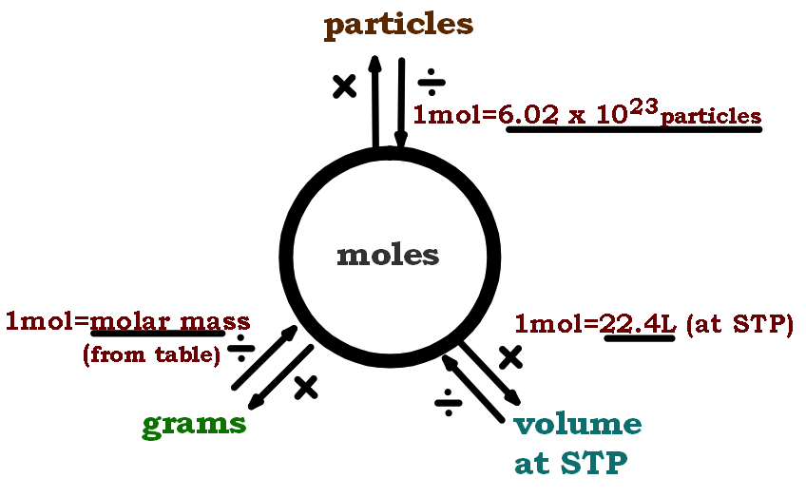

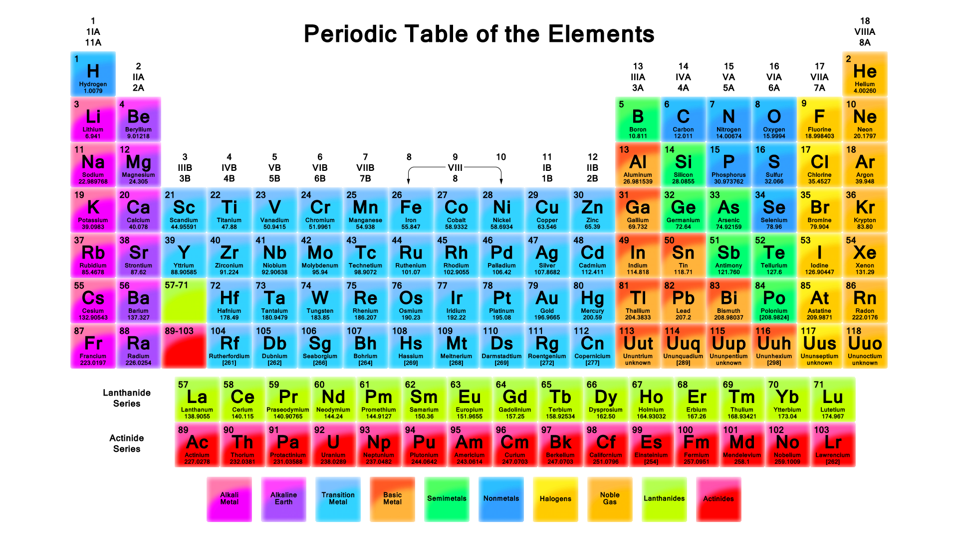

Common Polyatomic Ions
1+ Charge |  | 1- Charge |  | 2- Charge |  | 3- Charge |  | Transition Metals
NH₄⁺ | ammonium | NO₂⁻ | Nitrite | CO₃²⁻ | Carbonate | PO₃³⁻ | Phosphite | Formula | Stock | Latin
H₃O⁺ | hydronium | NO₃⁻ | Nitrate | SO₃²⁻ | Sulfite | PO₄³⁻ | Phosphate | Cu⁺ | Copper (I) | Cuprous
 |  | OH⁻ | Hydroxide | SO₄²⁻ | Sulfate | AsO₃³⁻ | Arsenite | Cu²⁺ | Copper (II) | Cupric
 |  | CH₃COO⁻ | Acetate | SiO₃²⁻ | Silicate | AsO₄³⁻ | Arsenate | Fe²⁺ | Iron (II) | Ferrous
 |  | CrO₂⁻ | Chromite | C₂²⁻ | Carbide |  |  | Fe³⁺ | Iron (III) | Ferric
 |  | CN⁻ | Cyanide | C₂O₄²⁻ | Oxalate |  |  | Hg₂²⁺ | Mercury (I) | Mercurous
 |  | CNO⁻ | Cyanate | CrO₄²⁻ | Chromate |  |  | Hg²⁺ | Mercury (II) | Mercuric
 |  | CNS⁻ | Thiocyanate | Cr₂O₇²⁻ | Dichromate |  |  | Pb²⁺ | Lead (II) | Plumbous
 |  | MnO₄⁻ | Permanganate | O₂²⁻ | Peroxide |  |  | Pb⁴⁺ | Lead (IV) | Plumbic
 |  | ClO⁻ | Hypochlorite |  |  |  |  | Sn²⁺ | Tin (II) | Stannous
 |  | ClO₂⁻ | Chlorite |  |  |  |  | Sn⁴⁺ | Tin (IV) | Stannic
 |  | ClO₃⁻ | Chlorate |  |  |  |  | Cr²⁺ | Chromium (II) | Chromous
 |  | ClO₄⁻ | Perchlorate |  |  |  |  | Cr³⁺ | Chromium (III) | Chromic
 |  | BrO⁻ | Hypobromite |  |  |  |  | Mn²⁺ | Manganese (II) | Manganous
 |  | BrO₂⁻ | Bromite |  |  |  |  | Mn³⁺ | Manganese (III) | Manganic
 |  | BrO₃⁻ | Bromate |  |  |  |  | Co²⁺ | Cobalt (II) | Cobaltous
 |  | BrO₄⁻ | Perbromate |  |  |  |  | Co³⁺ | Cobalt (III) | Cobaltic
 |  | IO⁻ | Hypoiodite |  |  |  |  | Ni²⁺ | Nickel (II) | ---
 |  | IO₂⁻ | Iodite |  |  |  |  | Ni³⁺ | Nickel (III) | ---
 |  | IO₃⁻ | Iodate |  |  |  |  | Zn²⁺ | Zinc

DUE JULY 1
PART A. COMPOUNDS AND EQUATIONS
Balancing Ionic Compounds
Given the names of the elements that form a compound, determine their ionic charge and write the chemical symbols for the compound.
EX: Lithium Oxygen
Li₂O Li⁺ O²⁻

- Sodium Sulfur

- Potassium Chlorine

- Rubidium Sulfate

- Magnesium Nitrite

- Strontium Iodine

- Aluminum Perchlorate

- Ammonium Phosphate

- Hydronium Bromine

- Cupric Carbonate

- Iron (II) Iodate

- Ferrous hydroxide

- Ferric Nitrate

Given chemical symbols below, determine the ionic charges of each element and then write the balanced chemical symbol for each compound formed.

EX: Na ClO₃ Na₂CO₃

- H Pb²⁺

- Li NO₃

- Be CO₃

- H SO₃

- Ca N

- Cs Br

- Fe³⁺ F

- Ag⁺ Se

Naming Ionic Compounds
For each ionic compound, list the cation(s), anion(s), chemical formula, and electron dot structure

- sodium iodide Chemical Formula Electron Dot Structure

cations ______________

anions ______________

- magnesium chloride Chemical Formula Electron Dot Structure

cations ______________

anions ______________

- aluminum sulfide Chemical Formula Electron Dot Structure

cations ______________

anions ______________

- iron (III) oxide Chemical Formula Electron Dot Structure

cations ______________

anions ______________

- stannous bromide Chemical Formula Electron Dot Structure

cations ______________

anions _____________

- plumbic oxide Chemical Formula Electron Dot Structure

cations ______________

anions ___________
Balance Chemical Reactions
Rewrite each chemical equation with the correct coefficients necessary to balance the equation.
- NaCO₃(aq) + Ca(OH)(aq) _____ NaOH(aq) + _____ CaCO₃(s)

- KPO₄(aq) + _____ MgCl(aq) _____ Mg(PO₄) (s) + _____ KCl (aq)

- Cu (s) + ____ H₂SO₄ (aq) ____ CuSO₄ (aq) + ____ H₂O (l) + ____ SO₂ (g)

- FeS (s) + HCl (aq) FeCl (aq) + HS (g)

- Fe (s) + CuNO₃ (aq) Cu (s) + Fe(NO₃) (aq)

- KI (aq) + Cl₂ (g) KCl (aq) +I₂ (aq)

- Al (s) + S (s) AlS (s)

Reaction Types
This is an instructional sheet to help you understand chemical reactions and to be able to predict the products of chemical reactions.
There are 5 types of reactions in chemistry.
- Combustion
  - The combustion of an organic material
    - EX: C₃H₈ + 5O₂ 3CO₂ + 4H₂O
    - The products are always carbon dioxide and water. The only thing that changes is the organic material and the coefficients needed to balance the equation.
- Combination
  - A + B X
  - EX: 2Mg + O₂ 2MgO
- Single-Replacement
  - Use the Activity Series to determine if an elemental metal will replace the metal in a compound based upon the reactivity of the metals
    - EX: Fe + 2AgNO₃ Fe(NO₃)₂ + 2Ag
    - EX: Cu + Zn(NO₃)₂ X or NR
- Double-Replacement
  - The cations of two ionic compounds exchange anionic partners
    - EX: NaOH + HCl NaCl + HOH
- Decomposition
  - The opposite of a combination reaction
  - A compound decomposes into elements and compounds
  - Typical products include CO₂, H₂, O₂
    - EX: BaCO₃ BaO + CO₂
    - 2Zn(OH)₂ 2ZnO + 2H₂
    - Ni(ClO₄)₂ NiCl₂ + 8O₂
  - There are tests for each type of product formed

Predict the products. Identify the reaction type.
ALWAYS balance the equation.
- Zn²⁺ + Ca(OH)₂

- LiCl + KBrO₃

- C₂H₆ + O₂

- MgO + Δ

- Hydrogen + Oxygen

Balance and Identify Chemical Reactions
Balance each equation with coefficients (all componds should already be balanced) and identify the reaction type.
- Hf + N₂ Hf₂N₄

- Mg + H₂SO₄ MgSO₄ + H₂

- C₂H₆ + O₂ CO₂ + H₂O

- Pb(NO₃)₂ + NaI PbI₂ + NaNO₃

- Fe + O₂ Fe₃O₄

- Pb(NO₃)₂ PbO + NO₂ + O₂

- Hg(NO₃)₂ + NH₄SCN Hg(SCN)₂ + NH₄NO₃

- (NH₄)₂SO₄ + NaOH NH₃ + H₂O + Na₂SO₄

Predict the products, balance, and identify the type of reaction
- Al + H₂SO₄

- HCl + Ba(OH)₂

- Au + HCl
Decomposition and Synthesis Reactions

A synthesis reaction is the opposite of a decomposition reaction. This practice will help us recognize the products for common decomposition reactions
- Sodium + Oxygen

- Lithium + Sodium chloride

- Sodium chloride and heat

- Potassium chlorate

- Copper (II) + Oxygen

- Aluminum + Hydrogen chloride

- Magnesium + Oxygen

- Silver + Chlorine

- Aluminum oxide and heat

DUE AUGUST 1
PART B. STOICHIOMETRY
Stoichiometry Worksheet: Molecule to Mass/Mole
- How many molecules are there in 24 grams of FeF₃?

- How many molecules are there in 450 grams of Na₂SO₄?

- How many grams are there in 2.3 x 10²⁴ atoms of silver?

- How many grams are there in 7.4 x 10²³ molecules of AgNO₃?

- How many grams are there in 7.5 x 10²³ molecules of H₂SO₄?

- How many molecules are there in 122 grams of Cu(NO₃)₂?

- How many grams are there in 9.4 x 10²⁵ molecules of H₂?

- How many molecules are there in 230 grams of CoCl₂?

Stoichiometry Worksheet: Moles and Moles
- Carbon disulfide is an important industrial solvent. It is prepared by the reaction of coke with sulfur dioxide:
5C(s) + 2SO₂(g) -----> CS₂(s) + 4CO(g)

  - How many moles of CS₂ form when 6.3 mol of C reacts? THIS EXAMPLE IS DONE FOR YOU!

6.3mol C 1 mol CS₂ = 1.26 mol CS₂
5 mol C
- How many moles of carbon are needed to react with 7.24 moles of SO₂

- Silver can be made according to the following equation:
AgNO₃+ Ca Ca(NO₃)₂ + Ag
  - Balance the equation
  - Identify the type of reaction

  - If 35.3 moles of silver nitrate are reacted how many moles of silver are produced?

- How many moles of carbon dioxide are formed when 44-mol of CH₄ is burned?

- How many moles of calcium phosphate is formed when 32.5-mols of calcium nitrate reacts with sodium phosphate?

Stoichiometry Worksheet: Moles and Moles
- Car batteries are called lead storage batteries because of their use of large quantities of lead. These batteries utilize the following equation.
Pb + PbO₂ +2H⁺ + 2HSO₄⁻ 2PbSO₄ + 2 H₂O

- 32.5-g of ZnSO₄ reacts to form how many grams of BaSO₄ according to the following equation.
  - Balance the equation
  - Identify the type of reaction

- When sodium metal is added to water the resulting gas, Hydrogen can often explode. How many Liters of hydrogen gas is produced when 41.2-g of sodium is dropped into water. You must balance the equation in order to solve the problem.
Na + HOH NaOH + H₂

- 43.5-grams of barium sulfate is formed from the reaction of barium nitrate and sodium sulfate. How many moles of sodium sulfate reacted?
Stoichiometry Worksheet: Volume
- Barium oxide reacts with carbon dioxide to make Barium carbonate:
BaO + CO₂ BaCO₃
  - Balance the equation
  - Identify the type of reaction

  - If 23.4 moles of barium oxide react, how many liters of CO₂ are required at STP?

- Ammonia, (NH₃) is produced by reacting its elements with each other according to the following equation:
N₂ + H₂ NH₃
  - Balance the equation
  - Identify the type of reaction

  - If 34.3-L of nitrogen is reacted with hydrogen, how many liters at STP of ammonia will be formed?

- Calculate the volume of carbon dioxide produced when 250 g of pentane, C₅H₁₂, burn. Assume the carbon dioxide is cooled to STP.

- Propane is a gas used often for backyard grills. How many Liters of CO₂ is produced when 54.9-L of propane (C₃H₈) is burned according to the following equation. Again, you must balance the equation in order to solve the problem.
C₃H₈ + O₂ CO₂ + H₂O

Stoichiometry Worksheet: Grams
- 14.5-g of cesium explosively reacts with water to form hydrogen and cesium hydroxide. How many molecules of hydrogen were formed?

- How many molecules of chlorine are needed to react with 5.6 g of iron to form iron III chloride?

- What mass of ammonia, NH₃, is necessary to react with 2.1 x 10²⁴ molecules of oxygen when ammonia (NH₃) reacts with oxygen to form water and nitrogen dioxide?

- 22.8-g of NaOH is reacted with hydrochloric acid. How many grams of water is formed?

- 32.5-grams of iron III chloride reacts with silver nitrate. How many grams of silver chloride are formed?

Stoichiometry Worksheet: Grams
- 34.5-grams of Lithium reacts with Chromium III chloride. How many grams of lithium chloride is formed?

- 43.5-grams of copper II sulfate is reacted with barium nitrate. How many grams of precipitate are formed?

- Calculate the mass of silver needed to react with chlorine to produce 84 g of silver chloride.

- Silver nitrate reacts with sodium chloride to make the silver chloride and sodium nitrate. When 2.53 grams of silver nitrate is reacted. How many grams of silver chloride are formed?

- When 3.25 g of copper II nitrate reacts with ammonium hydroxide. How many grams of the precipitate will form?

Stoichiometry Worksheet: Limiting Reactants
1. When 114.0 g of iron and 292.7 g of chlorine gas reacts, iron(III) chloride is formed.
a. Write a balanced equation

b. How many grams of Iron (III) chloride is formed

c. What is the limiting reactant?

d. How much excess reagent is left over at the end of the experiment?

2. 20 L of oxygen react with 1.0L of methyl alcohol, CH₃OH.
a. Write a balanced equation

b How many liters of water will be formed at STP?

c. What is the limiting reactant?

d. How much excess reagent is left over at the end of the experiment?

Stoichiometry Worksheet: Limiting Reactants
3. 25 g of hydrazine, N₂H_{4(l)}, and 66 g of hydrogen peroxide, H₂O_{2(l)}, react to produce nitrogen gas and water.
a. Write a balanced equation

b. How many grams of nitrogen are produced?

c. What is the limiting reactant?

d. How much excess reagent is left over at the end of the experiment?

4. 22.5 grams of lithium reacts with 33.5 grams of aqueous aluminum sulfate. This is a single replacement reaction.
a. Write a balanced equation.

b. How many grams of lithium sulfate will be formed?

c. What is the limiting reactant?

d. How much excess reagent is left over at the end of the experiment?

Stoichiometry Worksheet: Percent Yield
1. 15.5-g of NH₄Cl reacts with an excess of AgNO₃. In the reaction 35.5-g AgCl is produced. NH₄NO₃ is the other product. What is the percent yield?

2. Potassium Chlorate decomposes according to the following reaction.
2KClO₃ 2KCl +3 O₂
- In an experiment 32.5-g of KClO₃ is decomposed and 15.2-g of KCl is formed. What is the percent yield?

3. Nitrogen gas reacts with hydrogen gas to make ammonia (NH₃). 15.5-L of N₂ reacts at STP to make 30-L of ammonia. What is the percent yield?

- What is the percent yield of oxygen gas if 54L of O₂ can be obtained from the thermal decomposition of 500.0 g of potassium chlorate?
KClO₃ → KCl + O₂

Stoichiometry Worksheet: Mixed Problems
1. How many grams of water are formed when 12.5-g of hydrogen reacts with oxygen?

2. How many liters of carbon dioxide are formed when 12.3-g of sodium carbonate reacts with 2.0-L of hydrogen chloride. The reaction is printed below:
Na₂CO₃ + HCl NaCl + H₂O + CO₂

3. How many grams of precipitate are formed when 24.3-g of zinc nitrate reacts with 20.5-g of sodium phosphate?

4. How many liters of oxygen are produced when 3.25-g of KClO₃ decomposes into KCl and O₂?

